**TIC TAC TOE**

Prisha Sondhi (RA2111026010391)

Ruchi Shah (RA2111026010387)

Neil Malhotra (RA2111026010393)

**AIM:**

The tic-tac-toe game is played on a 3x3 grid the game is played by two players, who take turns. The first player marks moves with a cross, the second with a circle. The player who has formed a horizontal, vertical, or diagonal sequence of three marks wins. The program should draw the game board, ask the user for the coordinates of the next mark, change the players after every successful move, and pronounce the winner.

**ALGORITHM:**

1. Include the header files.
2. Define a global array name square and it will be of size 10.
3. Define the array square number here from 1 to 9 and each number represent the position in the square.
4. Checkwin is to check whether we have a winner or not so another function will be draw board that will be used to draw the board on our screen.
5. Define a main function here.
6. Define a variable player equal to 1, and choice.
7. This player variable is used to keep the track of the player.
8. i in a variable is used to keep the track of the progress of the game.
9. This i value is used to check whether the game is in progress or not.
10. Choice variable is used to take choice from the player meaning in which position and the player wants to place the mark.
11. Define another character variable that is mark.
12. Apply while condition and I is equal to minus 1.
13. Use draw board function.
14. Use ternary operator so the value of player will be player modulo 2.
15. Checking the value of player divided by two is equal to zero or not.
16. If the value is zero then it will return false and if the value is one then it will return true and if it is not divisible by 2 then the player will be one otherwise player will be 2.
17. The input from the user is percent d that will be going to be either player 1 or player 2
18. Scan this and place it in the choice variable.
19. Scan this value.
20. Check if else statement to check what the choice is enter by the user. If choice is equal to 1 and value in first position in square is equal to character 1 then we are going to place
21. Mark in this position.
22. If the choice enter by user is 1 then the first position is the square one, in the first position. There is still the value one that indicates that if the value is still one then that position is vacant and there is no mark there.
23. Else if choice is equal to 2. In this square 2 our position 2 is 2 then we are going to place the mark in that.
24. Do this for all the positions from 3 to 9.
25. Now we will copy else if condition 5 times.
26. Edit these lines according to the program.
27. If the user enters the choice other than value from 1 to 9 so else we are going to print invalid option.
28. Decrement the value of the player once and now return to the game.
29. Use check win function as it returns integer value. this function will return one if there is aa winner and will be returning minus one if the game is in progress and will be returning 0 if the game has been drawn.
30. Increment the value of the player.
31. If the player is equal to one then the mark will be “X” otherwise it will be “0”
32. Change the mark for player 1 and 2 for that we are using terminal operator here.
33. If the value is equal to 1 then we have winner so we are going to print player 1 won.
34. Decrease the value of player because in this loop the value of the player is incremental after the user has given the choice.
35. Create a function called board.
36. Write the program for displaying the board in the function.
37. Initialize this function in the main function.

**FLOWCHART:**



**SOURCE CODE:**

#include <stdio.h>

#include <conio.h>

char square[10] = {'o', '1', '2', '3', '4', '5', '6', '7', '8', '9'};

int checkwin();

void board();

int main()

{

int player = 1, i, choice;

char mark;

do

{

board();

player = (player % 2) ? 1 : 2;

printf("Player %d, enter a number: ", player);

scanf("%d", &choice);

mark = (player == 1) ? 'X' : 'O';

if (choice == 1 && square[1] == '1')

square[1] = mark;

else if (choice == 2 && square[2] == '2')

square[2] = mark;

else if (choice == 3 && square[3] == '3')

square[3] = mark;

else if (choice == 4 && square[4] == '4')

square[4] = mark;

else if (choice == 5 && square[5] == '5')

square[5] = mark;

else if (choice == 6 && square[6] == '6')

square[6] = mark;

else if (choice == 7 && square[7] == '7')

square[7] = mark;

else if (choice == 8 && square[8] == '8')

square[8] = mark;

else if (choice == 9 && square[9] == '9')

square[9] = mark;

else

{

printf("Invalid move");

player--;

getch();

}

i = checkwin();

player++;

}while (i == - 1);

board();

if (i == 1)

printf("==>\aPlayer %d wins", --player);

else

printf("==>\aGame draw");

getch();

return 0;

}

/*********************************************

FUNCTION TO RETURN GAME STATUS

1 FOR GAME IS OVER WITH RESULT

-1 FOR GAME IS IN PROGRESS

O GAME IS OVER AND NO RESULT

**********************************************/

int checkwin()

{

if (square[1] == square[2] && square[2] == square[3])

return 1;

else if (square[4] == square[5] && square[5] == square[6])

return 1;

else if (square[7] == square[8] && square[8] == square[9])

return 1;

else if (square[1] == square[4] && square[4] == square[7])

return 1;

else if (square[2] == square[5] && square[5] == square[8])

return 1;

else if (square[3] == square[6] && square[6] == square[9])

return 1;

else if (square[1] == square[5] && square[5] == square[9])

return 1;

else if (square[3] == square[5] && square[5] == square[7])

return 1;

else if (square[1] != '1' && square[2] != '2' && square[3] != '3' && square[4] != '4' && square[5] != '5' && square[6] != '6' && square[7] != '7' && square[8] != '8' && square[9] != '9')

return 0;

else

return - 1;

}

/***************************************************************

FUNCTION TO DRAW BOARD OF TIC TAC TOE WITH PLAYERS MARK

***************************************************************/

void board()

{

system("cls");

printf("\n\n\tTic Tac Toe\n\n");

printf("Player 1 (X) - Player 2 (O)\n\n\n");

printf(" | | \n");

printf(" %c | %c | %c \n", square[1], square[2], square[3]);

printf("_____|_____|_____\n");

printf(" | | \n");

printf(" %c | %c | %c \n", square[4], square[5], square[6]);

printf("_____|_____|_____\n");

printf(" | | \n");

printf(" %c | %c | %c \n", square[7], square[8], square[9]);

printf(" | | \n\n");

}

/***************************************************************

END OF PROJECT

***************************************************************/

**OUTPUT:**

1. 3x3 Grid:

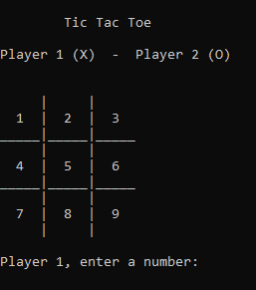

1. Draw:

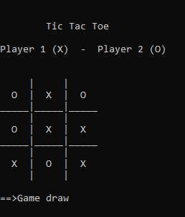

1. Player 1 (X) wins:

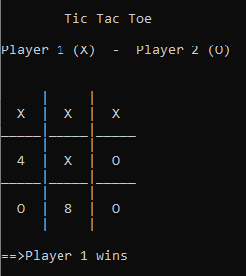

1. Player 2 (O) wins:

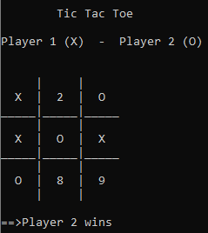

1. Invalid move:

